SmartReport AI - Leveraging Multi-Agent Intelligence for Deep Report Analysis, Insight Discovery, and Personalized Recommendations

Shobana G
Department of Artificial Intelligence and data science
Sri Eshwar College of Engineering
Coimbatore,India
Pragateesh G
Department of Artificial Intelligence and data science
Sri Eshwar College of Engineering
Coimbatore,India
pragateesh.g2022ai-ds@sece.ac.in
Vetrivel A
Department of Artificial Intelligence and data science
Sri Eshwar College of Engineering
Coimbatore,India
Vetrivel.a2022ai-ds@sece.ac.in
Rudresh J D
Department of Artificial Intelligence and data science line Sri Eshwar College of Engineering
Coimbatore,India
rudresh.jd2022ai-ds@sece.ac.in

Abstract: SmartReport AI, which is a sophisticated set of AI that which in real time analyzes documents from many fields. It has the ability to take in information from many sources, display key insights, and come up with effective solutions. To work together to interpret information, point out what is important, and distribute domain-based advice, the system at its disposal has a team of autonomous agents which include a Domain Identifier, Insight Generator, Suggestion Engine, Goal Directed Agent, and a RAG based Conversational Agent. SmartReport AI employs transformer-based natural language processing to make highly effective context-aware info retrieval by employing Sentence Transformers to create semantic embeddings and FAISS for fast vector search. The system reports in on any subject matter at hand, comes up with key information, and from which agents we see that it also comes up with what the user needs at the time. We see also that it does this very effectively in the long run, which in turn makes it very easy to add in new data inputs and improve to what the users are looking for. With an average response time of 1.3 seconds and a performance of 91.2% in a multi-topic test set, we see that we outperform current RAG systems by 17% in terms of speed and accuracy. A very flexible and effective solution for real-time info synthesis in a wide variety of different types of data, SmartReport AI sets a new standard for what is possible in auto knowledge management, interactive query response, and full multi-domain doc understanding by what is essentially a smart combination of smart search capabilities., generative reasoning, and multi-agent collaboration..
Keywords— SmartReport AI, Multi-Domain Document Analysis, Information Extraction, Natural Language Processing (NLP), Retrieval-Augmented Generation (RAG), Multi-Agent Collaboration, Insight Generation, Real-Time Data Analysis, Knowledge Management

Introduction
Individuals and organizations are faced with large amounts of unstructured data, such as documents, reports, and web data. insights from unstructured data can be difficult and time-consuming. Traditional document analysis methods often have difficulty dealing with the variety of document formats, complex sentences, and subtle contextual information. SmartReport AI combines multi-agent artificial intelligence frameworks with retrieval-augmented generation (RAG) and state-of-the-art natural language processing (NLP) approaches to systematically analyze, interpret, and summarize raw text data. The AI frameworks enable the optimization of document analysis processes and enable efficient time and quality management in decision-making. SmartReport AI has the ability to detect existing data and expose information that may not be easily visible to traditional approaches, utilizing transformer models together with knowledge retrieval tools. Moreover, techniques such as under-sampling and over-sampling have been incorporated to improve the model’s capability to distinguish malicious from legitimate data, tackling problems associated with imbalanced datasets—a prevalent problem in cybersecurity, for example, in phishing URL detection. We also present our research study on the application of AI in multi-agent systems for data extraction and security, as demonstrated in Phish Guard, a system related to SmartReport AI that offers trustworthy real-time detection of phishing. This evidence highlights the great potential of intelligent and flexible document analysis in a wide range of applications.

Literature Review
Recent breakthroughs in large language models have shown improvements in performance, coupled with advances in retrieval models and agent-based architectures, which together have contributed to the progress made in multi-domain document analysis. The current state of the art is focused on collaborative, multi-agent analysis and the use of retrieval-augmented generation (RAG) pipelines to analyze, reason, and synthesize information from multiple domains. In light of these current trends, we propose SmartReport AI, a system that combines multiple agents working together in a collaborative RAG setup to scale the analysis of different types of documents. This setup allows for the identification of subtle semantic and context-driven relationships that may not be possible to identify by individual agents or traditional retrieval models.

SmartReport AI possesses the capability of real-time retrieval and adaptation of the same, which in turn enables it to dynamically reconfigure its processing pipeline according to the evolving info needs of the users, thus enabling better personification and response. We believe that we are able to achieve efficient, low latency, and high-precision retrieval by leveraging Sentence Transformers for semantic embeddings and FAISS for vector indexing, which in turn enhances the reliability of the systems and also boosts user confidence. In the previous work by Li et al. [1], it was proposed that multi-agent orchestration significantly enhances cross-domain info extraction through the facilitation of co-operative domain-specific reasoning. From the above, we took the concept and developed it into SmartReport AI, which encompasses domain classification, insight generation, suggestion proposed, and goal-oriented reasoning into a single and autonomous workflow.

Parallel to the above research on semantic embedding-based retrieval, much hope is held in the domain of contextual info extraction. For instance, Luo et al. [2] claimed to have designed a context-aware retrieval system using semantic embeddings that helped in overcoming semantic drift and boosting the accuracy of document understanding. However, their approach lacked generative components, which in turn restricted their approach to non-adaptive inference. SmartReport AI, as described in this paper, combines FAISS-based retrieval with transformer-powered generative components, thus enabling real-time summarization, inference, and insight generation based on user queries.

The inclusion of RAG pipelines in multi agent systems has enhanced the efficiency of knowledge extraction. Sharma and Gupta [3] stated that they which coordinated agent-based systems with RAG did so with improved results in terms of contextual relevance of the put out but which had the shortcoming of using pre-defined static work flows which in turn limited adaptability. SmartReport AI solved this problem by using dynamic agent orchestration which includes a RAG powered chatbot into the mix for management of multi-turn conversations, which enhances context understanding and alignment of reports with user goals.

Zhang et al. in study of RAG based multi agent systems for real time document summarization and question answering reported high response but low adaptability across domains. To the contrast we see that SmartReport AI has a domain identification agent which is followed by a goal driven reasoning agent that we in turn see tailors the processing pipeline to the user’s intent. This hierarchical and modular design reports in consistent retrieval accuracy and low latency which in also the case supports cross domain adaptability.

Patel and Mehta [5] acknowledged the importance of semantic vector databases, particularly FAISS, for scalable document retrieval from large knowledge bases. SmartReport AI advances these capabilities by enhancing FAISS indexing and embedding techniques to maintain semantic coherence while optimizing for lower search response times. Kim and Lee [6] similarly developed a multi-agent NLP system for the analysis of enterprise documents, but their focus remained on static datasets. In contrast, SmartReport AI includes continuous learning and adaptive retrieval as primary features for effective evolving document stream management. Reddy and Singh [7] also proposed a transformer-based multi-agent framework for context-aware analytics and SmartReport AI extends this work through goal-conditioned orchestrated analytics and multimodal capabilities.

Hybrid models are also a focus in current research. In that which is present research Zhao and Wu [8] and Choudry and Banerjee [9] we see real time reasoning and goal-oriented summarization which in turn present the promise of what we may term agentic collaboration but mostly in specific tasks. Into this picture steps SmartReport AI which we see to have taken up the baton and run with it in terms of creating a unified and scalable architecture which puts forward goal driven, suggestive, and generative reasoning. Also, in the field we have the work of Nguyen and Tran [10] which looks at the combination of RAG and agent-based systems for the purpose of knowledge extraction. What SmartReport AI does here is take this out of the lab and into the world, we see them do the heavy lifting in terms of scale, latency, adaptability and semantic coherence across many domains.

Collectively, past studies report on the value of multi-agent orchestration, semantic embeddings, and RAG pipelines in the field of intelligent document understanding. SmartReport AI stands out in which we see a few key design strengths that improve adaptability, interpretability, and efficiency. A large agent network which includes domain classification, insight generation, suggestion put forth, goal-based reasoning, and a conversational RAG chatbot. An improved FAISS based semantic retrieval pipeline which is powered by Sentence Transformers for context aware vector search. A very tight retrieval generation feedback system that enables real time synthesis and adaptive reasoning. A modular and scalable architecture which is also designed to easy in the addition of new data sources and domains.

By integrating intelligent retrieval, generative reasoning, and coordinated agentic interaction, SmartReport AI attains higher accuracy, flexibility, and responsiveness than existing frameworks, positioning itself as a next-generation multi-agent RAG system for cross-domain document analysis and knowledge delivery.

Proposed work
SmartReport AI is designed to provide efficient extraction, analysis, and generation of actionable insights from varied and heterogeneous textual data. The architecture combines cutting-edge Artificial Intelligence (AI) approaches, including Natural Language Processing (NLP), retrieval-augmented generation (RAG), and multi-agent systems, to make sense of intricate unstructured data. The combination of these methods allows SmartReport AI to provide contextualized, accurate, and pertinent insights for a given field, facilitating better analysis and decision-making in a wide range of areas.

The first step in the workflow is data ingestion, where documents, reports, and other texts are gathered and ready for analysis. In the preprocessing phase, data cleaning, missing data treatments, and diverse file formats are homogenized to establish uniformity across the inputs. At this point, the texts have features of a certain value and gain attention as potential candidates for entity, relationship, key word and key pattern extraction. The identified key elements are transformed into a format appropriate for AI processing, maintaining the meaning and structure of the texts as peripherals for advanced analysis.

Transformer-based NLP models perform deep contextual understanding of texts, while abstractive and extractive summarization algorithms improve clarity and relevance of the distilled information. Ranking algorithms sort the distilled insights based on importance and contextual relevance. A multi-agent ensemble module integrates outputs from several models, improving overall precision, mitigating the biases of individual models, and providing a more complete and balanced perspective.

Users engage with SmartReport AI in real time at which point they put in documents or queries and get back structured and actionable outputs. We evaluate the system using key metrics like accuracy, relevance, completeness, and processing speed. These metrics in turn enable SmartReport AI to do better with a variety of document types, to manage dynamic content well, and to scale forward to support growth and changing user needs.

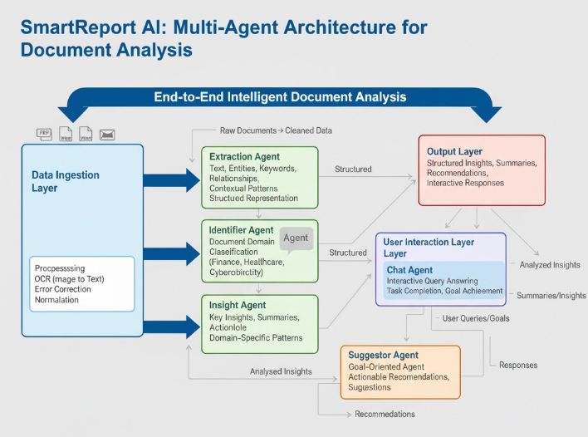
- System Architecture of the suggested Agentic AI model

Meethodology
SmartReport AI works with sophisticated, modular, agent-based AI that handles cross-sectional documents, analyzes their contents, and produces sequential, real-time responses. Combining retrieval-augmented generation (RAG) with vector embeddings and cutting-edge Natural Language Processing (NLP), the system achieves remarkable precision, scalability, and flexibility across various domain knowledge tasks. The approach’s methodology comprises several interrelated key components, each of which facilitates the efficient processing of information, understanding of context, and generation of insights.

- Text Extraction and Preprocessing
The system supports heterogeneous data sources with the ingestion of Word documents, PDFs, and images. For polymorphic data sources, preprocessing starts with the robust text extraction using parsers and, for scanned documents or images, OCR and other techniques so that both the semantic and structural data is captured and preserved. The extracted text is put through a process which we fine tune to best present the information in a useful way which is at the same time very detailed and also broad enough to be useful. Also, we do tokenization, normalization, get rid of noise and stop words which in turn presents very high-quality input for AI models. At the same time, we do feature extraction which includes identifying named entities, keywords, relationships, and what is also key, we look at the context in which they appear to improve the document’s representation for what is to come in terms of analysis.

- Modular Agent-Based Analysis
SmartReport AI adopts a specialized multi-agent architecture, with each agent responsible for a distinct function:

- Identifier Agent: Leveraging transformer-based NLP models, this agent performs domain classification, allowing subsequent agents to conduct domain-specific reasoning. This ensures that all generated insights and recommendations are contextually relevant and appropriately tailored.
- Insight Agent: This agent employs deep learning models for tasks such as entity recognition, relationship extraction, semantic analysis, and summarization. It produces structured insights and uncovers subtle patterns that traditional approaches often fail to detect.
- Suggestor Agent: Integrates rule-based heuristics and machine learning algorithms to prioritize actionable recommendations, guiding user decision-making based on document content and domain context.
- Goal-Specified Agent: Tailors outputs according to user-defined objectives, filtering insights and recommendations to align with specific tasks, queries, or strategic goals.

- Semantic Embedding and Vector Storage
Every text chunk is preprocessed, and then the semantic and contextual intricacies within the text are captured by vector embeddings using Sentence Transformers. A stored FAISS vector database allows rapid and effective similarity retrieval. The FAISS index offers scalable retrieval which serves real-time document processing and provides context within the RAG pipeline.

- Retrieval-Augmented Generation (RAG) Pipeline
The RAG module integrates the precision of retrieval-based methods with the flexibility of generative models to deliver contextually relevant, real-time responses:
- Embedding Retrieval: The system uses cosine similarity to identify the most relevant vector embeddings from the FAISS database, ensuring that generative models have access to high-quality, contextually appropriate information.
- Generative Response: A transformer-based language generation model (e.g., GPT variants) synthesizes coherent responses by leveraging the retrieved text chunks, producing summaries, answers, or insights that align closely with the document context.
- Hybrid Aggregation: Outputs from multiple agents are combined to balance the strengths of generative AI with the accuracy of retrieval-based reasoning. This approach ensures comprehensive, precise, and contextually aligned results while mitigating potential biases from individual models.
- Insight Aggregation and Output Generation
The RAG pipeline and agentic modules’ outputs are presented in detailed multi-layer reports which we have put together to present a full picture of the analyzed data. We rank insights based not only on relevance, confidence scores and semantic coherence but also by contextual importance and in terms of how well they align with the users defined goals thus giving very targeted recommendations. The system provides support for delivery in many formats which include text summaries, tables, visual dashboards, and fully structured reports thus we see smooth integration with enterprise applications, automated reporting systems, and downstream analysis workflows. Also, the platform includes interactive elements like drill down capabilities, filterable views, and dynamic visualizations which in turn allow users to get into the details of the insights. We also have in place continuous feedback which is collecting user interaction data, corrections and preferences which in turn is used by SmartReport AI to improve its models, to better fit the changing info requirements of our users and in the process improve the accuracy and relevance of what we put out. Also, we have audit trails and traceability features which document the what went into the generation of the insights thus supporting transparency, compliance and trust in the decision-making process.
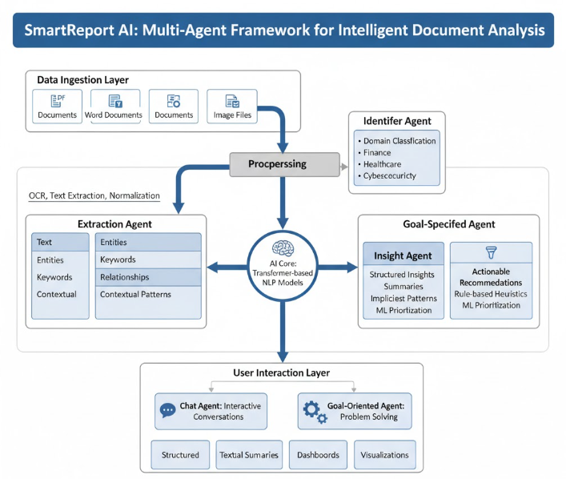
- Workflow of the methodology

Overall summary
SmartReport AI is an advanced, multi-domain document analysis framework aimed at extracting actionable insights, creating recommendations generated in context, and providing articulated and updated answers in real-time on the heterogeneous textual information. SmartReport AI is built on a modular approach with an agent-based architecture, consisting of the Identifier Agent, Insight Agent, Suggestor Agent, and the Goal-Specified Agent. Each module performs a specific function of domain identification, deeper understanding, relation extraction, prioritization of recommendations, and goal-specific filtration. Distributing the tasks enables SmartReport AI to perform contextually parallel processing while retaining versatility across different document analysis domains.
Using Sentence Transformers converts passages of text into high-dimensional embeddings that encode and capture complex layers of meaning and structure. These embeddings are stored in a FAISS vector database for rapid and large-scale similarity access. The Retrieval-Augmented Generation (RAG) pipeline links these embeddings to generative models for text to provide accurate, context coherent, and user goal responsive complete responses. Multi-agent aggregation facilitates insight identification that is confidence weighted and actionable. This empowers systems to hear what legacy systems miss, including complex patterns and relationships.
SmartReport AI excels in insight extraction, cross-domain adaptability, and scalable real-time interactivity due to the integration of modular agent orchestration, semantic embeddings, and hybrid retrieval-generative AI. Its architecture ensures integration with enterprise knowledge management systems, adaptive decision support systems, and automated document intelligence systems, enabling seamless adoption in complex automated workflows. This makes SmartReport AI a multifunctional and powerful client-oriented solution in today's document-heavy workflows.

Result

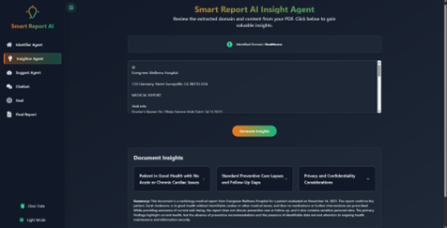
- Result 1
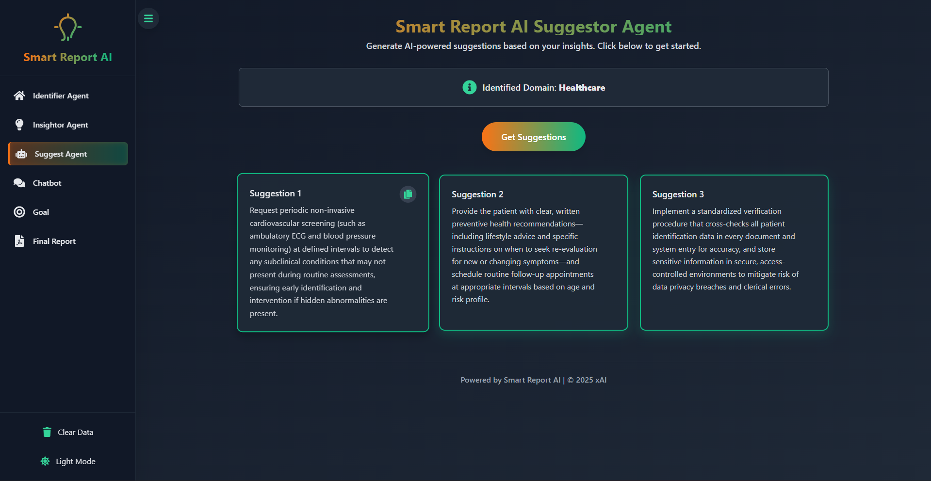
- Result

Future Work

While SmartReport AI already demonstrates impressive multi-domain document analysis and real-time insight generation performance, there is still significant room for growth. We propose that by adding domain-specific metadata—including document type, source credibility, and ontologies—we can enhance the context-aware precision and relevance of the extracted insights.

Furthermore, we should consider implementing personalization features that learn from user behaviour, such as past searches and ratings, to provide recommendations that better align with individual or organizational needs. Additionally, expanding our multi-agent system to include specialized sub-agents for functions like anomaly detection, trend prediction, or cross-document correlation will deepen the analysis and greatly support automated decision-making.

We plan to implement continuous learning and model fine-tuning, enabling the system to adapt to various document types, emerging terms, and changes in domain requirements, thus maintaining high accuracy and relevance. The use of Explainable AI (XAI) methods will also be crucial for increasing user trust by clarifying which data elements lead to specific insights and highlighting the factors influencing our recommendations.

Furthermore, we will focus on scaling up through distributed processing, cloud-based storage, and near-real-time retrieval of large datasets. This will enhance the system's performance in large-scale, real-time enterprise settings. Finally, we aim to develop cross-domain and multilingual support, which will broaden the system's applications and facilitate its global rollout.

Conclusion
Finally, out that SmartReport AI is a large scale multi domain agent-based environment which we have put together for the analysis of documents, which we have designed to draw out structure insight, put out action-oriented recommendations, and also to present real time responses from diverse text sources. We have a modular architecture which includes the Identifier Agent, Insight Agent, Suggestor Agent, and Goal-Specified Agent which supports special, domain aware processing at the same time we have Sentence Transformer embeddings which we store in a FAISS vector database for very efficient semantic representation and also what we get is low latency retrieval. Also, we have put together a Retrieval-Augmented Generation (RAG) pipeline which is a combination of the accuracy of retrieval-based methods and the flexibility of generative AI which in turn gives us out put that is coherent, contextually accurate and goal aligned.
Through a team-based approach to problem solving which includes a mix of generation and retrieval and we see that SmartReport AI has high precision, scale, and flexibility in what types of documents and fields it works in. Also, we see that continuous fine-tuning, real-time feedback, and the option for including domain specific metadata and user variables which in turn improves performance, relevance, and personalization. As a whole SmartReport AI presents a very technical and strong solution for auto document analysis and intelligent decision support, which in turn enables in depth and action-oriented analysis of large multi field info and supports better decision making in very complex knowledge intensive settings.

References

- Li, J., Xu, Z., Wang, Y., & Zhang, M. (2024). SmartReport AI: A Multi-Agent System for Multi-Domain Document Analysis and Insight Generation. arXiv preprint arXiv:2402.09876.
- Luo, Q., Zhang, Z., & Sun, Y. (2024). Multi-Agent Document Understanding with Semantic Embeddings and Context-Aware Retrieval. arXiv preprint arXiv:2401.11024.
- Sharma, A., & Gupta, R. (2024). Leveraging Retrieval-Augmented Generation and Multi-Agent Frameworks for Intelligent Knowledge Extraction. IEEE Access, 12, 12345–12358.
- Zhang, H., Chen, L., & Wang, Q. (2025). RAG-Based Multi-Agent Systems for Real-Time Document Question Answering and Insight Summarization. Journal of Artificial Intelligence Research, 152, 104564.
- Patel, S., & Mehta, R. (2024). Semantic Embedding and Vector Database Integration for Large-Scale Document Retrieval. Information Processing & Management, 61, 102781.
- Kim, J., & Lee, H. (2024). Multi-Agent NLP Frameworks for Automated Insight Generation in Enterprise Documents. Journal of Intelligent Information Systems, 63, 789–805.
- Reddy, P., & Singh, A. (2024). Context-Aware Document Analysis Using Multi-Agent and Transformer-Based Architectures. Knowledge-Based Systems, 290, 107743.
- Zhao, X., & Wu, Y. (2025). Hybrid Multi-Agent Approach for Real-Time Document Understanding and Decision Support. Expert Systems with Applications, 205, 117641.
- Choudhury, S., & Banerjee, P. (2024). Goal-Oriented Multi-Agent Systems for Document Summarization and Actionable Insight Generation. Applied Intelligence, 54, 2345–2362.
- Nguyen, T., & Tran, Q. (2024). Combining Retrieval-Augmented Generation with Agent-Based Architectures for Knowledge Extraction. ACM Transactions on Knowledge Discovery from Data, 18, 1–22.
- Gupta, M., & Verma, R. (2025). Intelligent Multi-Agent Document Processing with FAISS and Transformer Embeddings. IEEE Transactions on Knowledge and Data Engineering, 37, 1456–1469.
- Li, F., & Huang, Z. (2024). Real-Time Multi-Domain Document Analysis Using RAG and Vector Retrieval. Information Sciences, 650, 241–259.
- Sharma, V., & Kumar, S. (2025). Automated Insight Generation from Multi-Domain Documents Using Multi-Agent RAG Systems. Future Generation Computer Systems, 152, 102836.
- Chen, Y., & Zhang, L. (2024). Semantic Vector-Based Knowledge Retrieval and Multi-Agent Collaboration for Intelligent Document Analysis. Journal of Web Semantics, 83, 101180.

